BPUIA Logging Demo

Overview of Solution

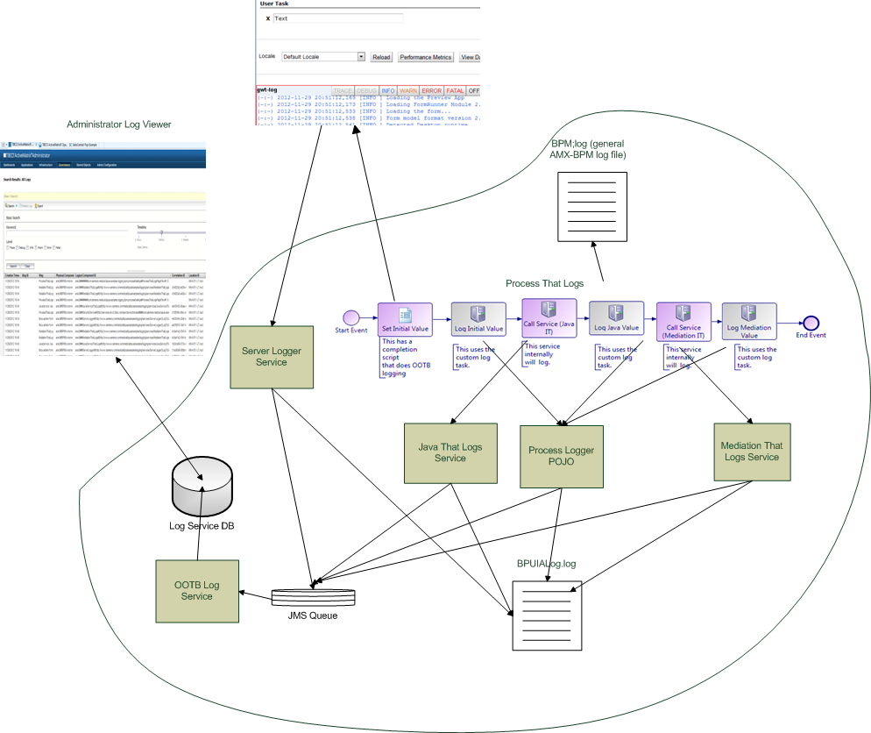

Source Code
- TIBCO Business Studio projects:
Project Name | Project Type | Major Components | Description
Services That Log | TIBCO SOA | 1. Server Logger Composite  2. Mediation That Logs Composite  3. Java Service That Logs Composite  4. Mediation implementation for #2 | 1 is a special service that logs on behalf of clients. We'll use it to allow the UI to persist client log.  2 and 3 are types of services in addition to their main function also do logging.  4 is a mediation. Uses mediation log task.
com.siemens.medical. bpuia.samples.logging. services. javaservicethat logscomposite | Java plugin | Java implementation of composite #2 above | Java implementation of composite #2 above.  Uses log4j.
com.siemens.medical. bpuia.samples.logging. services. serverlogger composite | Java plugin | Java implementation of composite #1 above | Java implementation of composite #1 above.  Uses log4j.
Process Logger POJO | Java plugin | Java POJO class used in ProcessThatLogs below. | Java class that exposes logging functionality for use by ProcessThatLogs below.  Uses log4j.
Process That Logs | TIBCO BPM | Pageflow | Contains pageflow that: (a) Invokes services 2 and 3 above; (b) Logs its milestones using ProcessLoggerPojo above, (c) Also logs its milestones using the built-in Log.write() Javascript function.  The pageflow also contains a user-task whose form invokes service #1 above to persist its client logs. The form also uses the built-in GWT logger. There is some attempt at limiting traffic.

- SOAPUi project to test each service
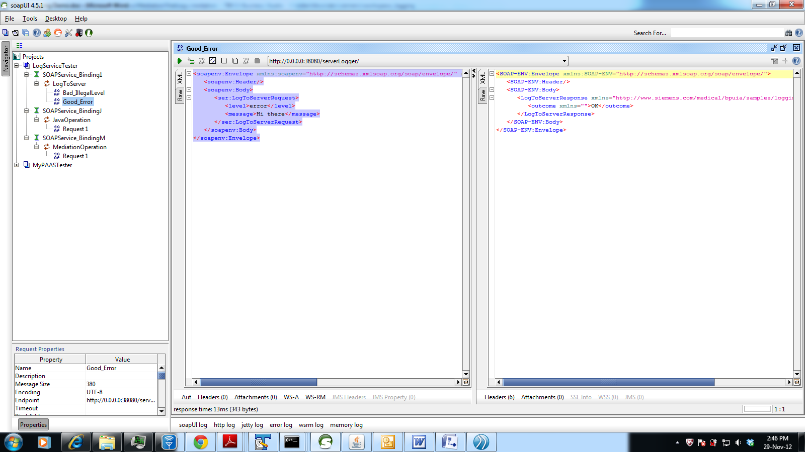

Administrator Configuration
- Appender: We'll log everything to a file called BPUIALog.log. Define an appender for it in Shared Objects | Logging Appenders:

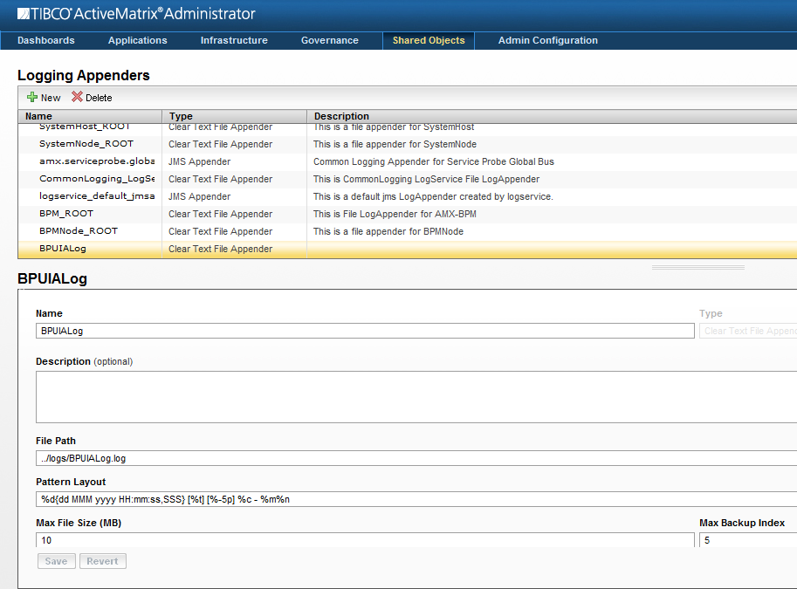

- Loggers: Add a logging configuration to the node (in our case, it's BPMNode) and attach appender to it. Also attach appender for logging service (logservice_default_appender); we'll need that using Log Viewer in administrator. Do this under Infrastructure | Nodes | BPMNode | Configuration | Logging Configurations. We're calling our logger "com.siemens.medical.bpuia.samples.logging" to apply to all of our services; each of those services uses this logger (or a "descendant" of it, to be precise).

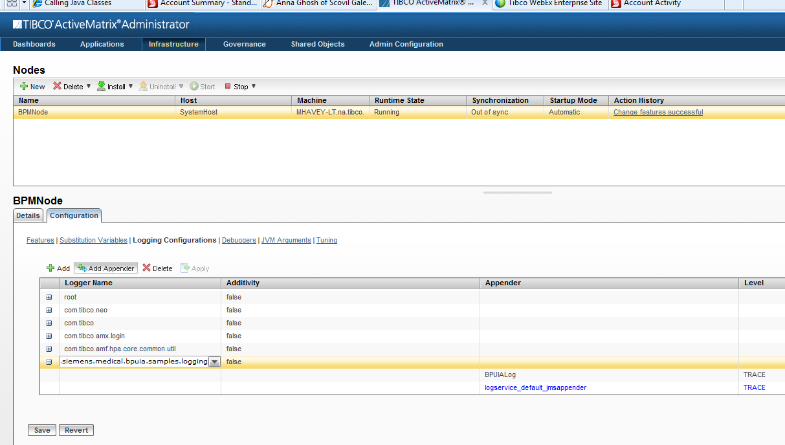

Note: If I don't want to configure the logger at the node level, I can set it at the level of each application. The logger above could have been configured for each of the following: ProcessThatLogs, JavaServiceThatLogs, ServerLogger.

But mediation's logger is different, because mediations use a fixed logger naming scheme:

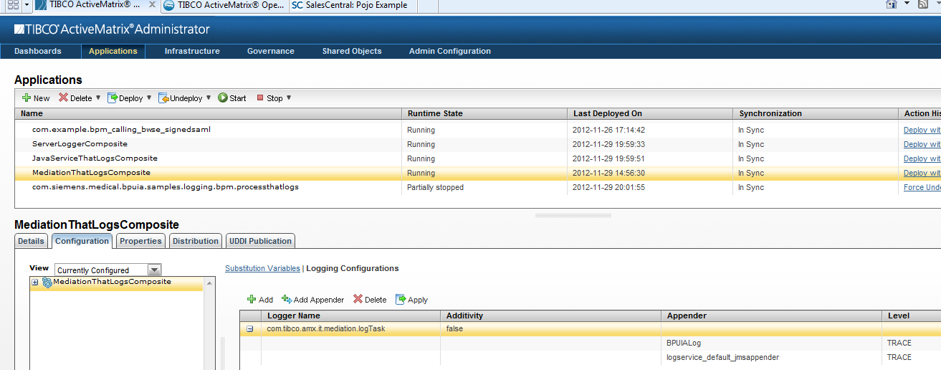

Two Logs!
- BPUIALog.log. You can trace this back to the process if you study it closely.

30 Nov 2012 10:28:40,662 [httpConnector_30] [ERROR] com.siemens.medical.bpuia.samples.logging.services.serverloggercomposite.ServerLoggerComponent - tibco-admin-Form calling server logger Mike was here
30 Nov 2012 10:28:43,957 [httpConnector_29] [INFO ] com.siemens.medical.bpuia.samples.logging.pojo.serverloggerpojo.ProcessLoggerPojo - ProcessThatLogs for process(id:pvm:0a102 name:PageflowThatLogs started:2012-11-30T10:28:32.930-05:00 user:tibco-admin) has X=Mike was here
30 Nov 2012 10:28:44,000 [Default Service Virtualization Thread_3] [INFO ] com.siemens.medical.bpuia.samples.logging.services.javaservicethatlogscomposite.JavaServiceThatLogsComponent - JavaService: input *Mike was here* output *MIKE WAS HERE*
30 Nov 2012 10:28:44,050 [httpConnector_29] [INFO ] com.siemens.medical.bpuia.samples.logging.pojo.serverloggerpojo.ProcessLoggerPojo - ProcessThatLogs for process(id:pvm:0a102 name:PageflowThatLogs started:2012-11-30T10:28:32.930-05:00 user:tibco-admin) has X=MIKE WAS HERE
30 Nov 2012 10:28:44,084 [Default Service Virtualization Thread_3] [INFO ] com.tibco.amx.it.mediation.logTask.MediationThatLogsComponent.MediationThatLogs.MediationOperation.InputPath.MediationLogIn - MediationThatLogsComponent.MediationThatLogs.MediationOperation.InputPath.MediationLogIn: MediationFlowProperties=<mediation:properties xmlns:mediation="http://com.tibco.amsb/mediation/1354121911008"/>
MessageContext =
MessageData=<MediationOperationRequestMsg xmlns="http://www.siemens.com/medical/bpuia/samples/logging/services/MediationThatLogs/">
<parameters>
<logs:MediationOperationRequest xmlns:logs="http://www.siemens.com/medical/bpuia/samples/logging/services/MediationThatLogs/">
<in xmlns="">MIKE WAS HERE</in>
</logs:MediationOperationRequest>
</parameters>
</MediationOperationRequestMsg>
MediationExchangeVariable=null
30 Nov 2012 10:28:44,087 [Default Service Virtualization Thread_3] [INFO ] com.tibco.amx.it.mediation.logTask.MediationThatLogsComponent.MediationThatLogs.MediationOperation.ReplyPath.MediationLogOut - MediationThatLogsComponent.MediationThatLogs.MediationOperation.ReplyPath.MediationLogOut: MediationFlowProperties=<mediation:properties xmlns:mediation="http://com.tibco.amsb/mediation/1354121911008"/>
MessageContext =
MessageData=<tns1:MediationOperationResponseMsg xmlns:tns="http://www.siemens.com/medical/bpuia/samples/logging/services/JavaServiceThatLogs/" xmlns:tns1="http://www.siemens.com/medical/bpuia/samples/logging/services/MediationThatLogs/">
<tns1:parameters>
<tns1:MediationOperationResponse>
<out>MMMMMIKE WAS HERE</out>
</tns1:MediationOperationResponse>
</tns1:parameters>
</tns1:MediationOperationResponseMsg>
MediationExchangeVariable=null
30 Nov 2012 10:28:44,132 [httpConnector_29] [INFO ] com.siemens.medical.bpuia.samples.logging.pojo.serverloggerpojo.ProcessLoggerPojo - ProcessThatLogs for process(id:pvm:0a102 name:PageflowThatLogs started:2012-11-30T10:28:32.930-05:00 user:tibco-admin) has X=MMMMMIKE WAS HERE

- Administrator Log Viewer: Messages read from database

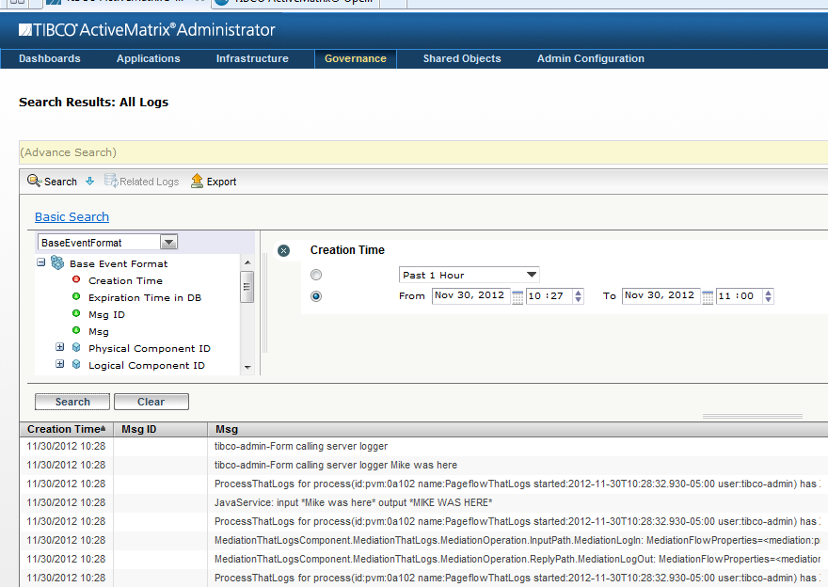

Further Discussion
- TIBCO's Common Logging and Exception (CLE) tool. For centralized logging and error handling.
- TIBCO's Hawk: System Management, including ability to scan logs for errors.
- BWSE Logging: Require Siemens environment in which BWSE is installed.
- TIBCO Backlog Items: Process Logging, Client-Side Logging

